The Zebra Experience Center has a distinct logo to brand the space and our function.

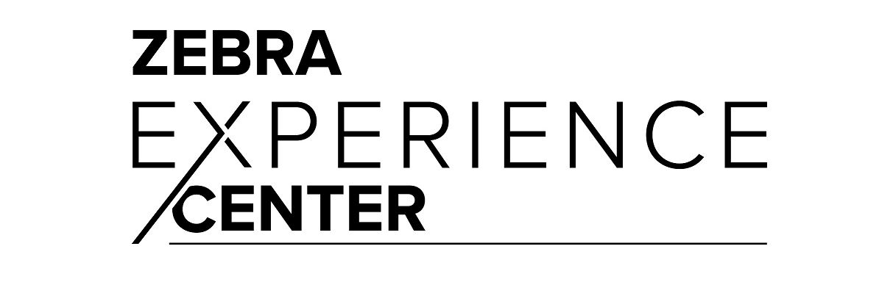

The 2022 theme for Zebra’s Briefing Program is Get with the Program Our way of reminding and reinforcing to sellers that Executive Briefings are everyone’s business.
